Template for Evidence(s)
UI GreenMetric Questionnaire
SAMPLE

University : ...
Country : ...
Web Address : …

[6] Education and Research (ED)

[6.14] Number of university sustainability program(s) with international collaborations (ED.7)

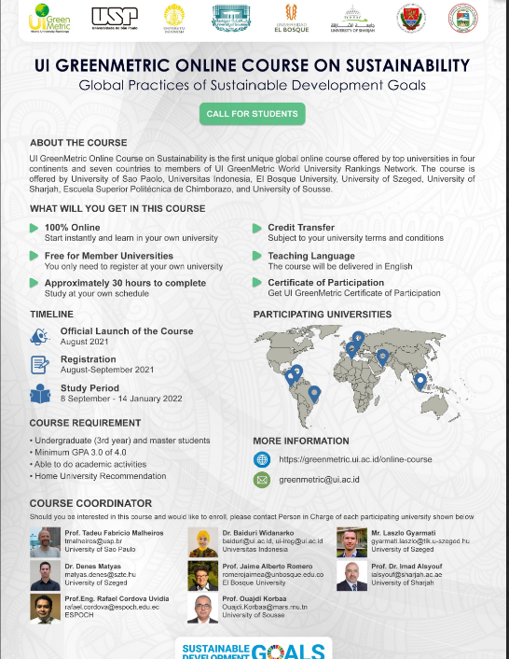 | 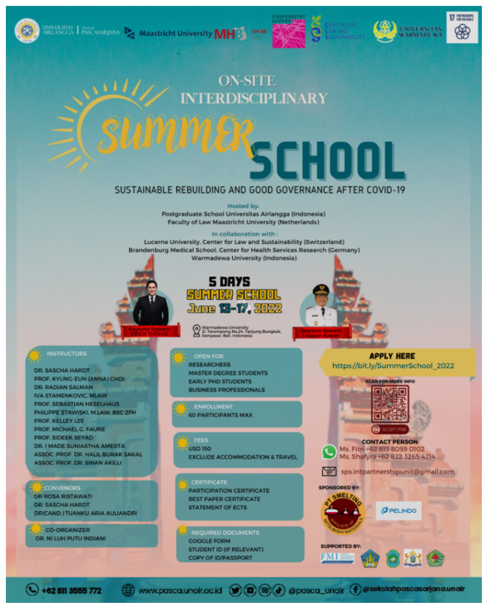
UI GreenMetric Online Course on Sustainability, with 7 Universities from 7 countries, Universitas Indonesia, El Bosque University, University of Szeged; University of Sao Paulo, University of Sharjah, ESPOCH, and the University of Sousse. | Interdisciplinary Summer School on Sustainable Rebuilding And Good Governance AFTER COVID-19, hosted by Universitas Airlangga (Postgraduate School), Maastricht University (Faculty of Law), Universitas Warmadewa (Faculty of Economics and Business)
The Project for Breeding Innovation in Chili Pepper and Tomato to Accelerate Sustainable Vegetable Production in Tropical Regions, by Japan International Research Center for Agricultural Sciences, Miyagi University, Universitas Padjadjaran, University of Tsukuba, Ministry of Agriculture Republic Indonesia and National Agency for Research and Innovation

Description:
(Please describe sustainability programs with international collaborations on your campus. The following is an example of the description. You can describe more related items if needed.)

UI GreenMetric Online Course on Sustainability
The course is designed as an undergraduate-level introduction to the most challenging question facing our generation: how can the world evolve in ways that are socially inclusive, environmentally durable, and financially viable? The course discusses the complex interplay between the economy, social life, and our planet's physical environment, as well as the consequences of human activities on the planet's environment and the solutions to face them. It contextualizes these challenges in different countries such as Brazil, Colombia, Ecuador, Hungary, Indonesia, Tunisia, and The United Arab Emirates.
Interdisciplinary Summer School on Sustainable Rebuilding And Good Governance AFTER COVID-19
Taking place in Bali, Indonesia, this summer school offers students from Indonesia and beyond the possibility to learn about and discuss the many challenges that lie ahead after the pandemic in a truly interdisciplinary fashion under a PBL approach. The summer school addresses a large array of topics, ranging from reopening tourism in a more sustainable way to restoring and safeguarding civil rights, from global vaccine equity to establishing financial disaster-resilience, from better health literacy to better international coordination in case of international travel restrictions and border closures.

The Project for Breeding Innovation in Chili Pepper and Tomato to Accelerate Sustainable Vegetable Production in Tropical Regions
The research proposal entitled "The Project for Breeding Innovation in Chili Pepper and Tomato to Accelerate Sustainable Vegetable Production in Tropical Regions" submitted by the Faculty of Agriculture, University of Padjadjaran in collaboration with the University of Tsukuba, Japan, is one of the collaborative research projects that successfully passed the selection in 2022 and will be funded by the SATREPS Program for 5 (five) years which will start in the 2023 fiscal year. The SATREPS program, which was designed by the Faculty of Agriculture, Padjadjaran University and the University of Tsukuba, has one of the research objectives: Assembling and disseminating new tomato cultivars that are tolerant to heat and chili resistant to Anthracnosa
A series of activities have been carried out on November 14 – December 2 2022, to prepare for the implementation of this Research Collaboration Project. Kick-off meetings and a number of coordination meetings have been carried out by the Faculty of Agriculture, Padjadjaran University and the University of Tsukuba both online and offline, at Padjadjaran University as well as in other related institutions. The SATREPS research collaboration also involves the National Research and Innovation Agency (BRIN), the Indonesian Ministry of Agriculture, Miyagi University, and the Japan International Research Center for Agricultural Sciences (JIRCAS).

Additional evidence link (e.g. for videos, more images, or other files that are not included in this file):

